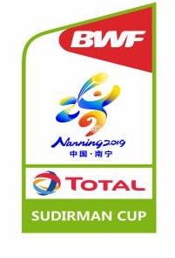
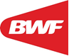

TOTAL BWF SUDIRMAN CUP 2019
NANNING (CHINA)
19-26 MAY 2019

PLEASE SEND THIS FORM TO ORGANIZING COMMITTEE BEFORE 12 April 2019
TAX: +0086 0771 2350123 PHONE：+0086 0771 2350022 EMAIL: Sudirmancup2019@163.com
VISA APPLICATION – BWF AGM DELEGATES

d

Member Associations whose delegates, players, officials and media requiring a visa to enter China, please complete this form. An invitation letter will be returned for your visa application.

Please allow for sufficient visa processing time in your region.

MEMBER ASSOCIATION
(Country)
CATEGORY
(BWF/Team/Media)

CONTACT PERSON |  | PHONE
EMAIL |  | ADDRESS

No. | Surname  (on passport) | Given Names  (on passport) | Gender | Nationality | Passport  No. | Expiry Date | Date of  Birth | Role
1
2
3
4
5
6

Please return this form to the organizing committee no later than 12th April 2019 to Sudirmancup2019@163.com

PLACE AND DATE | NBF STAMP | AUTHORIZED NBF SIGNATURE
………………………………………….. |  | ……… …………………..  PRESIDENT/ SECRETARY OF NBF UNDER BADMINTON WORLD FEDERATION

