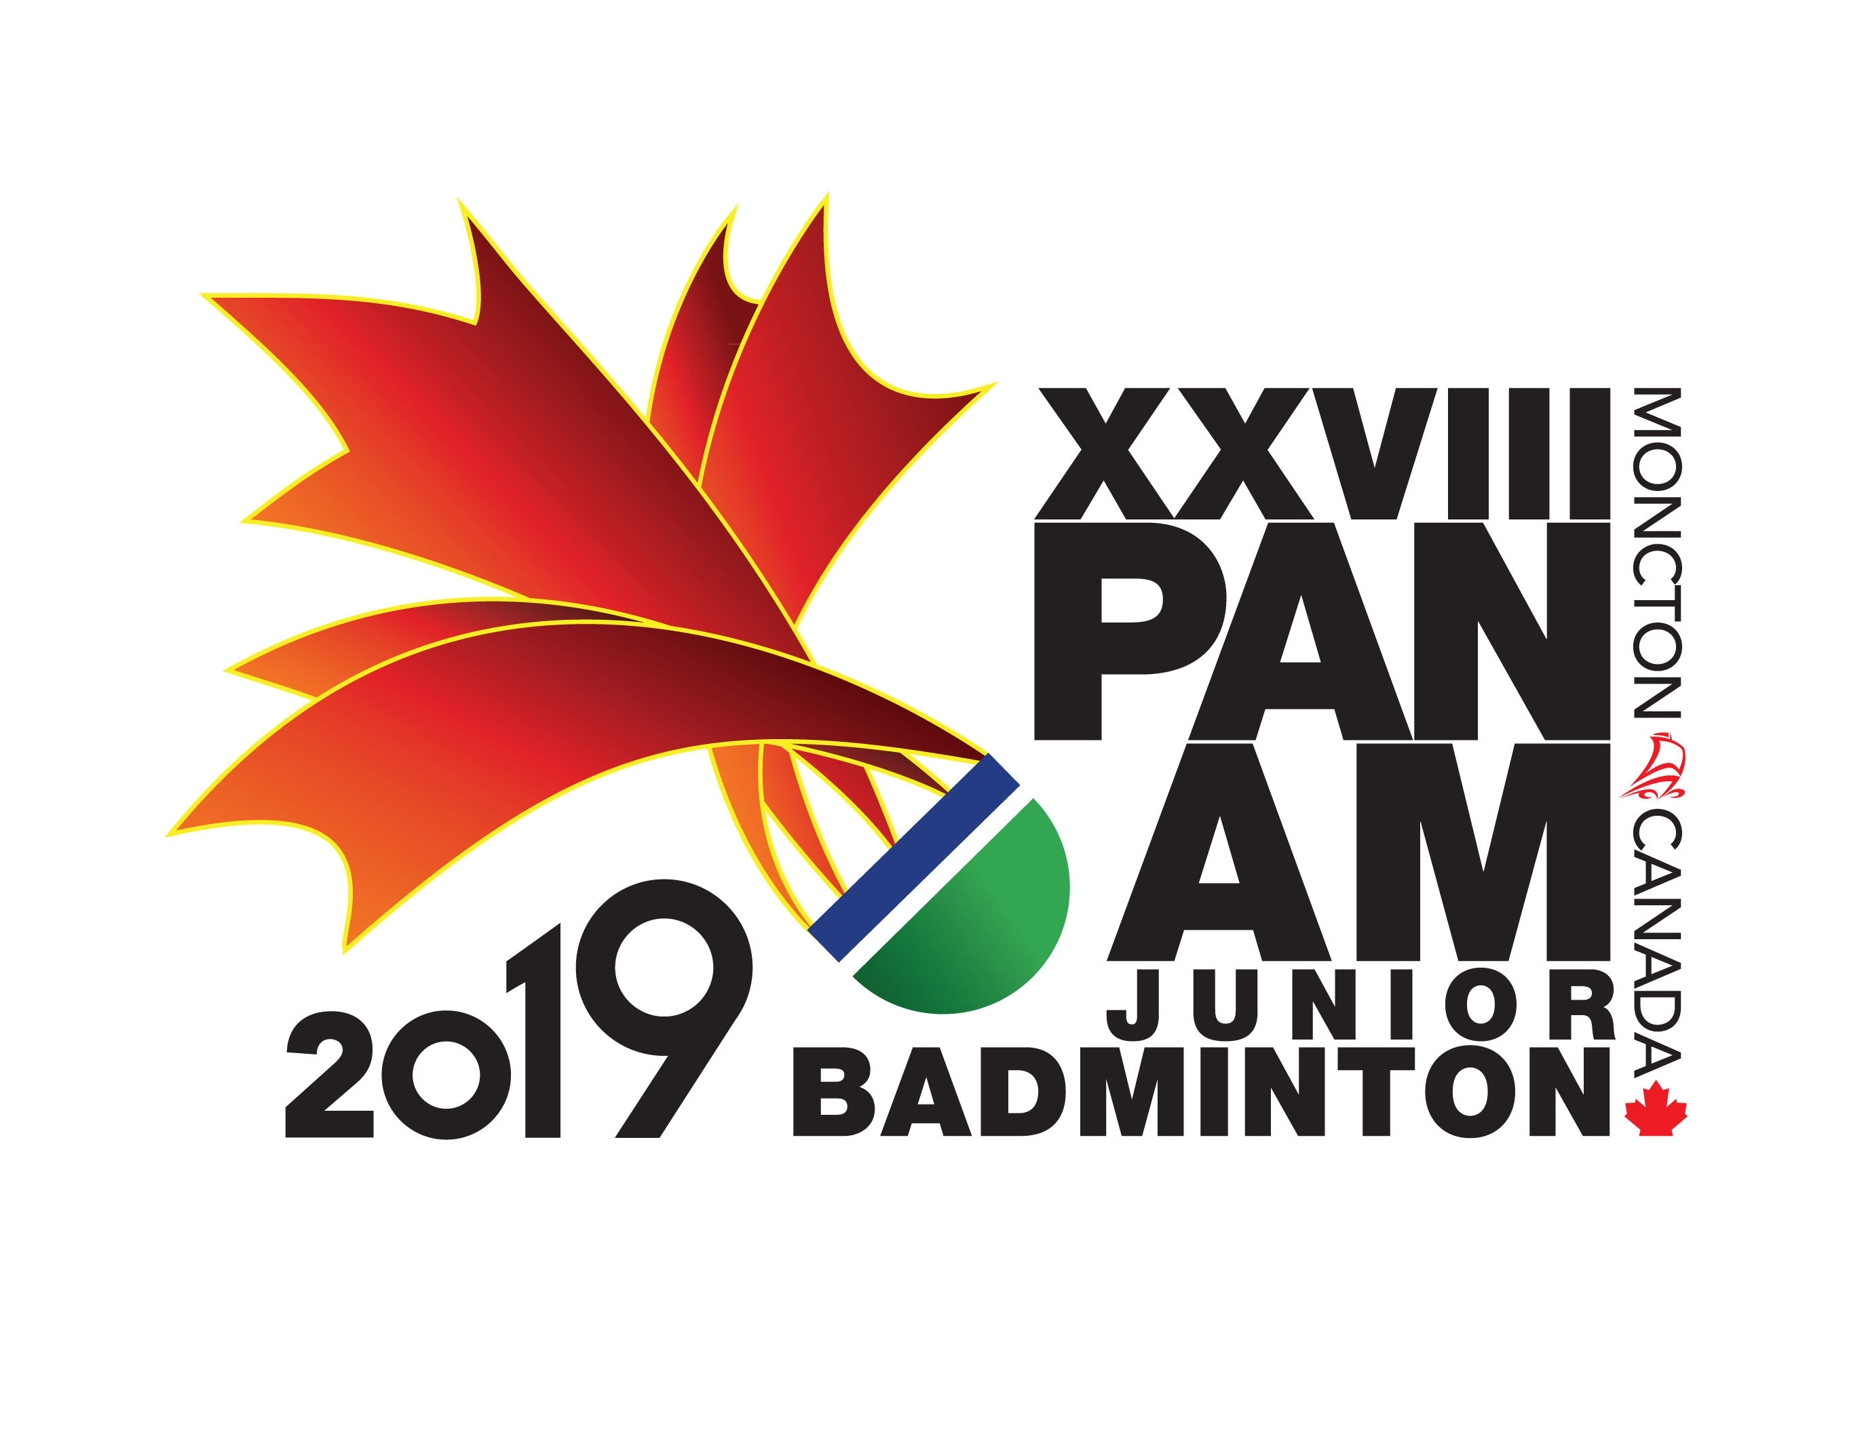
XXVII PAN AM JUNIOR CHAMPIONSHIPS 2019

ACCOMODATION INFORMATION AND FORM
(FORM ON PAGE 4)

Reservations:
- All reservations for participating teams, players, coaches, delegates, must be done directly by each Member Association.
- For reservation, complete and return this form to: events@badminton.ca
- Deadline for reservations: June 21, 2019
- Subject: 2019 Jr Pan Am Hotel Reservation (Name of Association)

Payments:
Associations should forward a 20% non-refundable deposit for accommodation by 21 of June, 2019 via Bank Transfer in US $ dollars direct to:

Beneficiary Name – Badminton Canada
Beneficiary Address – 700 Industrial Ave, Suite 401, Ottawa Ontario, Canada, K1G0Y9
Bank Name – TD Canada Trust
Address – 1547 Merivale Rd, Ottawa, Ontario, Canada, K2G4V3
SWIFT/BIC – TDOMCATTTOR
Account # – 3293 7307676

Associations should forward the remainder 80% of payment for accommodation by 1st of July, 2018.

Accommodations:
Badminton Canada is pleased to offer a wide range of accommodation options for the participants at the Championship. Accommodations will be distributed on a first come first served basis.

Badminton Canada has partnered with the University of Moncton to offer very affordable accommodations on campus. These facilities are a five-minute walk to the competition hall and practice hall. Rooms start as low as $31US per night. Please note that there is a limit number of rooms available at this location.

ROOM RATES per night
Name | Single | Double | Triple | Quad | Notes | Website
University of Moncton Residences | $31US | $62US | $93US | $124US | Optional meal plan available | LINK

Room Rate includes:
- All room rates include any applicable taxes – no tax rates will be applied in addition
- Internet Wi-fi
- Parking
- Airport to Hotel transport: shuttle transport will be arranged between official hotels and the Moncton International Airport
Please note that this service will only be applicable to participants who have made the reservation through the Organizer and by providing flight information.
- Internal transport: shuttle transport will be arranged between official hotels and the competition venue.
Please note that this service will only be applicable to participants who have made the reservation through the Organizer
- Check-in time is 1500 and check-out time is 1100

In addition, we have a wide range of hotel accommodations. Again, there are a limited number of rooms available at each hotel.

ROOM RATES per night
Name | Single | Double | Triple | Quad | Notes | Website
Holiday Inn Express and Suites | $165US | $175US | $185US* | $195US* | Breakfast Included | LINK
Hampton Inn and Suites | $165US | $175US | $185US* | $195US* | Breakfast Included | LINK
Four Points Moncton | $165US | $175US | $185US* | $195US* | No Breakfast | LINK
* shared beds

Room Rate includes:
- All room rates include any applicable taxes – no tax rates will be applied in addition
- Internet Wi-fi
- Breakfast Buffet (exception Four Points Moncton)
- Parking
- Airport to Hotel transport: shuttle transport will be arranged between official hotels and the Moncton International Airport
Please note that this service will only be applicable to participants who have made the reservation through the Organizer and by providing flight information.
- Internal transport: shuttle transport will be arranged between official hotels and the competition venue.
Please note that this service will only be applicable to participants who have made the reservation through the Organizer
- Check-in time is 1500 and check-out time is 1100

Meal Plan:
Badminton Canada has partnered with the University of Moncton to offer an affordable meal plan for all participants. Meals are all you can eat and everyone (players, coaches, support staff and parents) can all access healthy and affordable meals through the plan.

The daily rate for the plan is $45US per person per day for Breakfast, lunch and dinner.

Please complete the accommodation request form and submit to events@badminton.ca.

XXVII PAN AM JUNIOR CHAMPIONSHIPS 2019

HOTEL ROOMING LIST
for Delegates, athletes, team officials, coaches

CONTACT DETAILS
Country/Association
Contact Name
Address
Phone Number |  | Mobile Number
Fax Number |  | Email

RoomNo. | Name(s) |  | Name of Accommodations | Room Type | Designation | Date of Arrival | Date of Departure
RoomNo. | Please put all names sharing a room together under the same Room No.
RoomNo. | Family Name | First Name | U de Moncton Residences | S = Single | D = Delegate | yy-mm-dd | yy-mm-dd
RoomNo. | Family Name | First Name | Holiday Inn Express and Suites | D = Double | A = Athlete | yy-mm-dd | yy-mm-dd
RoomNo. | Family Name | First Name | Hampton Inn and Suites | T = Triple | TO = Team Official | yy-mm-dd | yy-mm-dd
RoomNo. | Family Name | First Name | Four Points Moncton | Q = Quadruple | C = Coach | yy-mm-dd | yy-mm-dd
1

2
3
4
5
6
7

8
9
10
11
12
13

14
15
16
17
18
19

